LABORATORY WORK 01
The Price of One Request
Student: Rustamova Radmila
Model used: Gemini 3.5 Flash-Lite

1. Objective
The purpose of this lab was to compare how the same support request is represented and priced in three languages. I first checked tokenizer behaviour and offline text size, then measured the real input and output token usage through the Gemini API.
For the API part of the lab I used Gemini 3.5 Flash-Lite instead of Claude, since I had access to a Gemini API key. Parts 0 and 1 remained unchanged because they do not require an API.

1. Prediction and measured value
As an initial check, I compared the same texts with two tokenizers:
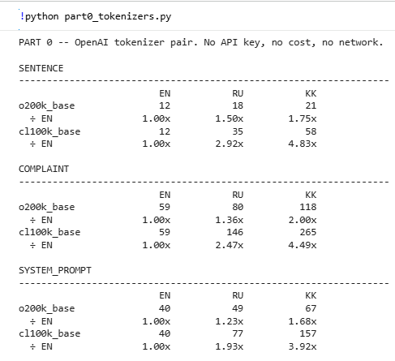
The output showed that the same content can require very different numbers of tokens depending on both language and tokenizer. Kazakh produced the largest token count in both cases.

Then I measured basic text properties offline:
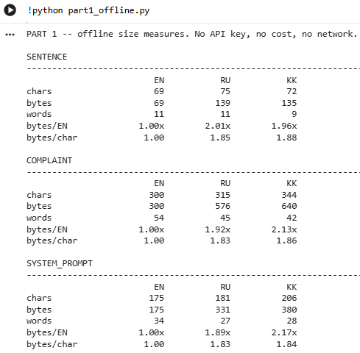

Thanks for this output before measuring the actual Gemini token usage, I made a simple prediction based on UTF-8 byte size. In UTF-8, Latin letters generally use 1 byte, while Cyrillic letters, including the Kazakh-specific letters used in the text, use 2 bytes. This difference can also be seen in the bytes/char values from Part 1.
For the complaint, the byte ratio was 1.92× for Russian relative to English and 2.13× for Kazakh relative to English. Therefore, I predicted that the Russian version would require about 1.92× as many tokens as the English version, while the Kazakh version would require about 2.13× as many.
RU / EN ≈ 1.92×
KK / EN ≈ 2.13×
I used byte size rather than character or word count because it showed a much clearer difference between the three languages. However, I did not expect the tokenizer to follow byte size exactly. Tokenizers work with learned token and subword patterns rather than directly with characters, bytes, or words, so the byte ratios were only a rough estimate.
The actual Gemini token counts were then measured with:
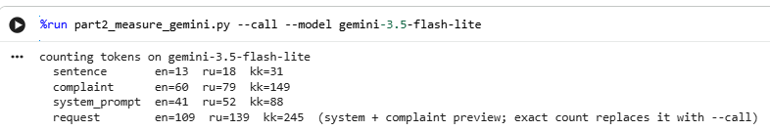
The byte-based estimate predicted the general increase, but not the exact token ratios. Russian was tokenized more efficiently than expected, while Kazakh required more tokens than the byte ratio suggested. This confirms that tokenization depends on learned subword units rather than directly on characters, words or bytes.

2. Annual cost
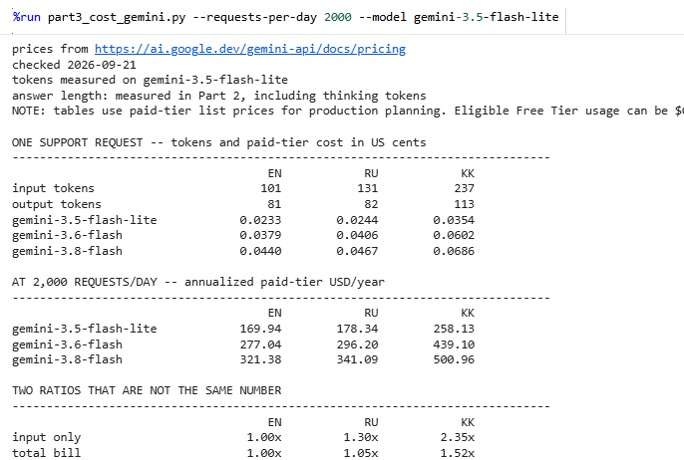
For Gemini 3.5 Flash-Lite, the annual paid-tier cost at 2,000 requests per day was:
Language | Cost per year | Relative total bill
English | $169.94 | 1.00×
Russian | $178.34 | 1.05×
Kazakh | $258.13 | 1.52×
I used 2,000 requests per day as a reasonable example of a moderate-volume customer support queue operating throughout the year.
Although the Kazakh request used 2.35× more input tokens than English, its total bill was only 1.52× higher in this run. This is because total cost depends on both input and output tokens. The Kazakh response contained 113 output tokens, compared with 81 for English, so the difference in total cost was smaller than the input-token ratio alone might suggest.
At the same volume, using Kazakh instead of English on Gemini 3.5 Flash-Lite would cost approximately $88.18 more per year.

3. Production Model Choice
For a Kazakh-language support queue, I would use Gemini 3.5 Flash-Lite for the workload tested in this lab. At 2,000 requests per day, its projected annual cost for Kazakh is $258.13, compared with $439.10 for Gemini 3.6 Flash and $500.96 for Gemini 3.8 Flash.
The Kazakh response generated in Part 2 was relevant to the support request and did not invent missing customer or contract information. Instead, the model explained that additional information was required before a specific answer could be given. For a simple support scenario, this level of quality is sufficient while keeping the API cost relatively low.
Only Gemini 3.5 Flash-Lite was directly measured in Part 2. The costs of Gemini 3.6 Flash and Gemini 3.8 Flash were calculated using the same measured token volumes, so they should be treated as cost projections rather than direct model comparisons.

4. Cost-Reduction Lever
One cost-reduction method that was not tested in this lab is prompt compression. Shortening repeated system instructions and unnecessary context would reduce the number of input tokens sent with every request and therefore lower the overall API cost.

5. AI-Use Declaration
I used ChatGPT during this laboratory work to adapt the original API workflow to the Gemini API and troubleshoot errors.
The actual experiments were run by me in Google Colab using my own Gemini API key. I executed the tokenizer scripts, offline measurements, Gemini API calls and cost calculations myself. The numerical results included in this report come from my own program outputs.

